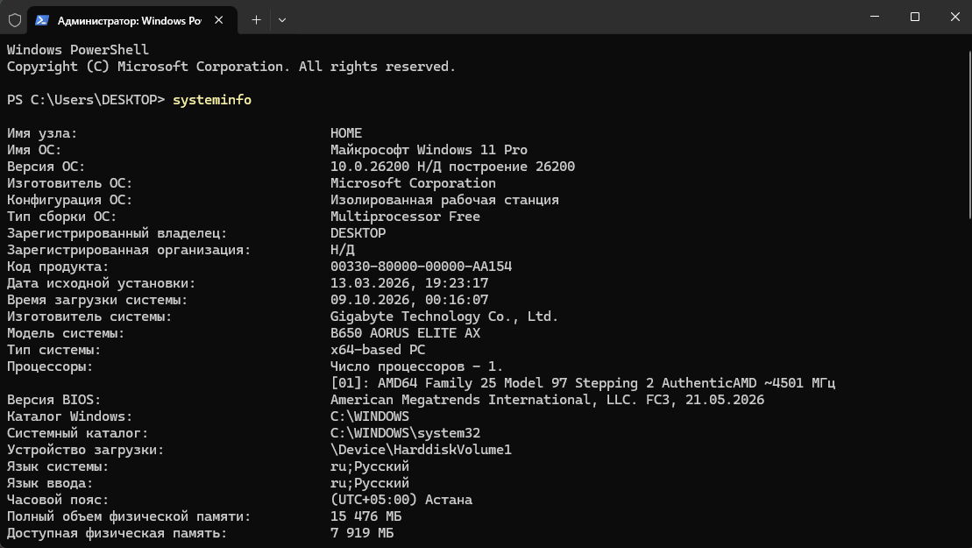
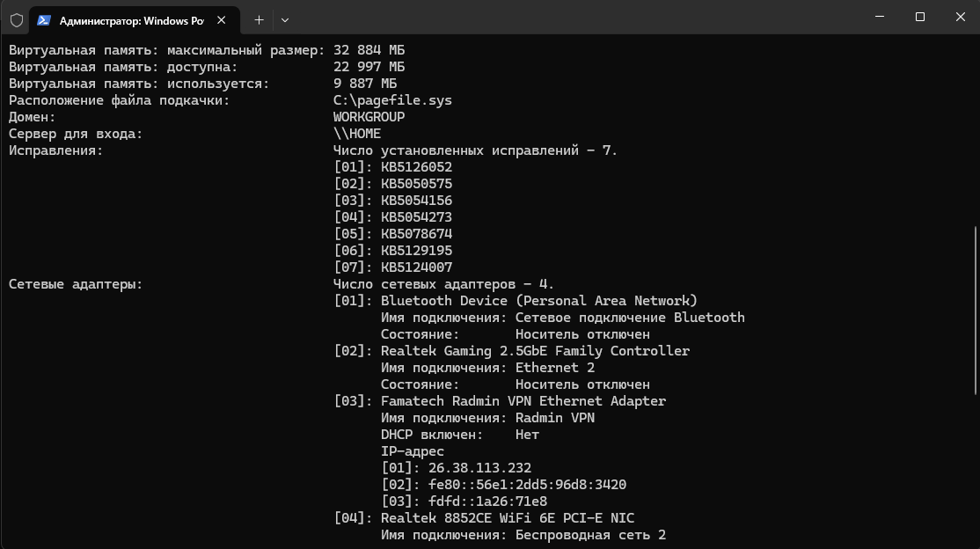
The `systeminfo` command displays key computer specifications, such as the processor model, motherboard, Windows version, BIOS version, and more.

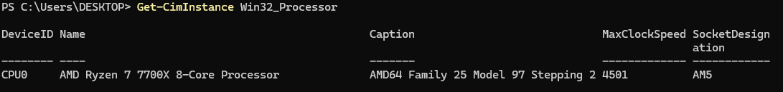Get-CimInstance Win32_Processor shows you the full processor name, caption, and socket.

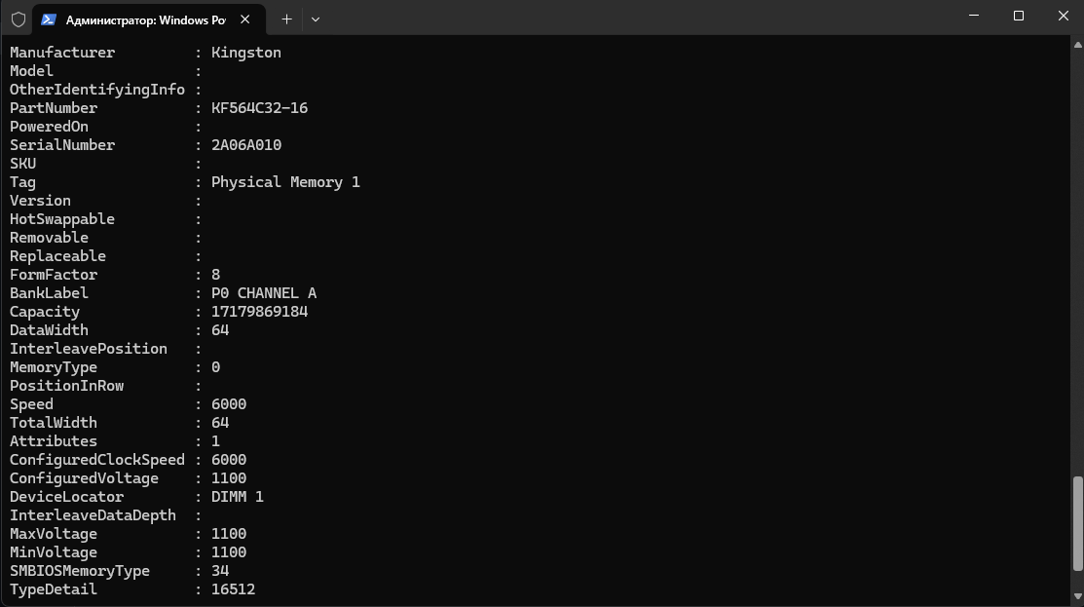
Get-CimInstance Win32_PhysicalMemory can show you all information about your RAM like capacity, speed, manufacturer
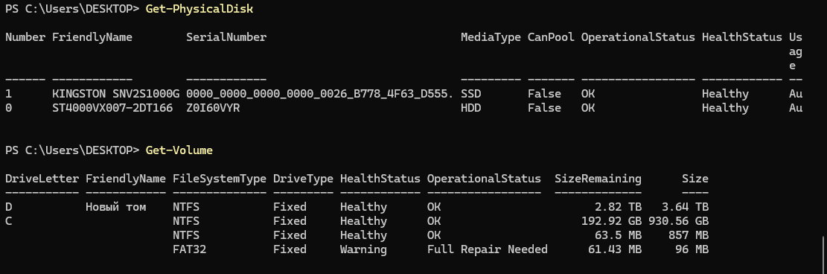
Get-PhysicalDisk shows you how many disks you have, their serial Number, Health Status
And what type of disk is this
Get-Volume shows size of your disk and size remaining
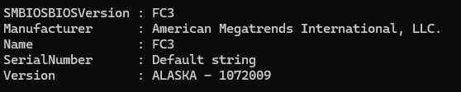
Get-CimInstance Win32_BIOS shows information about your bios and version

